E2 Working on a farm in Grenada

Before watching  1 Describe the photo. Guess what the object is and what it is used for.  P |  | 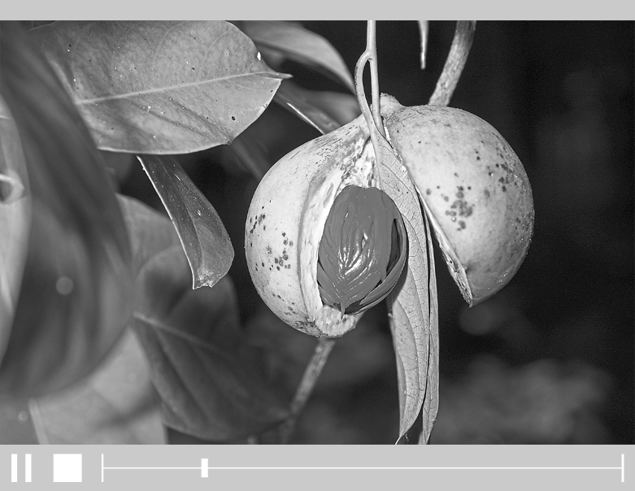


V1
While watching
2 Watch the beginning of the film and find out if your guess in task 1 was correct.

R

3 Watch the whole film and complete the following sentences.

1. It is already very hot at six o’clock in the …
2. To do his job the reporter only needs his …
3. The island of Grenada is called the …
4. We use spices for baking and …
5. Nutmeg is Grenada’s biggest …
6. A nutmeg can be harvested when you can see a … spot.
7. If you cannot knock a nutmeg off the tree, you have to …
8. The red mace can also be used as a …
9. In Grenada they grow tree fruit such as …
10. They also grow vegetables such as …
11. Keith sells his products to …
12. He keeps some of the products for …

After watching
4 Would you be interested in working on a farm like the ones in the film in your summer holidays or in a gap year? Say why or why not.

