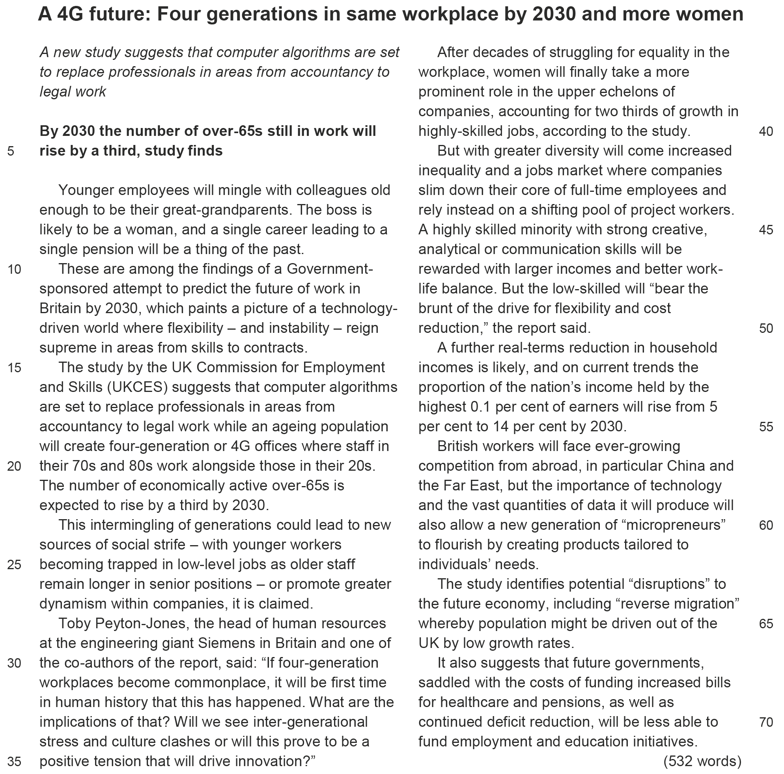

Annotations
line 24: strife (fml) – conflict
line 38: echelon – rank or position in an organisation
line 43: to slim down – to reduce
line 48: to bear the brunt – to take the worst part of a situation
line 68: saddled with – burdened with

Tasks
1 Content/Comprehension
Point out the major changes in the workplace that are predicted in the article.
2 Form/Analysis
Examine the structure and style of the article. In doing so, consider the writer's choice of words when describing future workplaces.
3 Comment/Text production
Choose one of the following tasks:
a) Write an email to the author of the article, Cahal Milmo, in which you either favourably or critically deal with some of the ideas mentioned in his article.
b) Comment on the vision of four-generation offices. To what extent do you find this viable or undesirable from your generation’s point of view?
4 Mediation
Your English course is working on the joint project ‘The world of work – currents trends’ with your partner school in the UK. Together with your British partner you are working on the problem of outsourcing. You have come across Petra Steinberger’s article in the Süddeutsche Zeitung, which you find interesting. Present a short summary and send it to your partner.

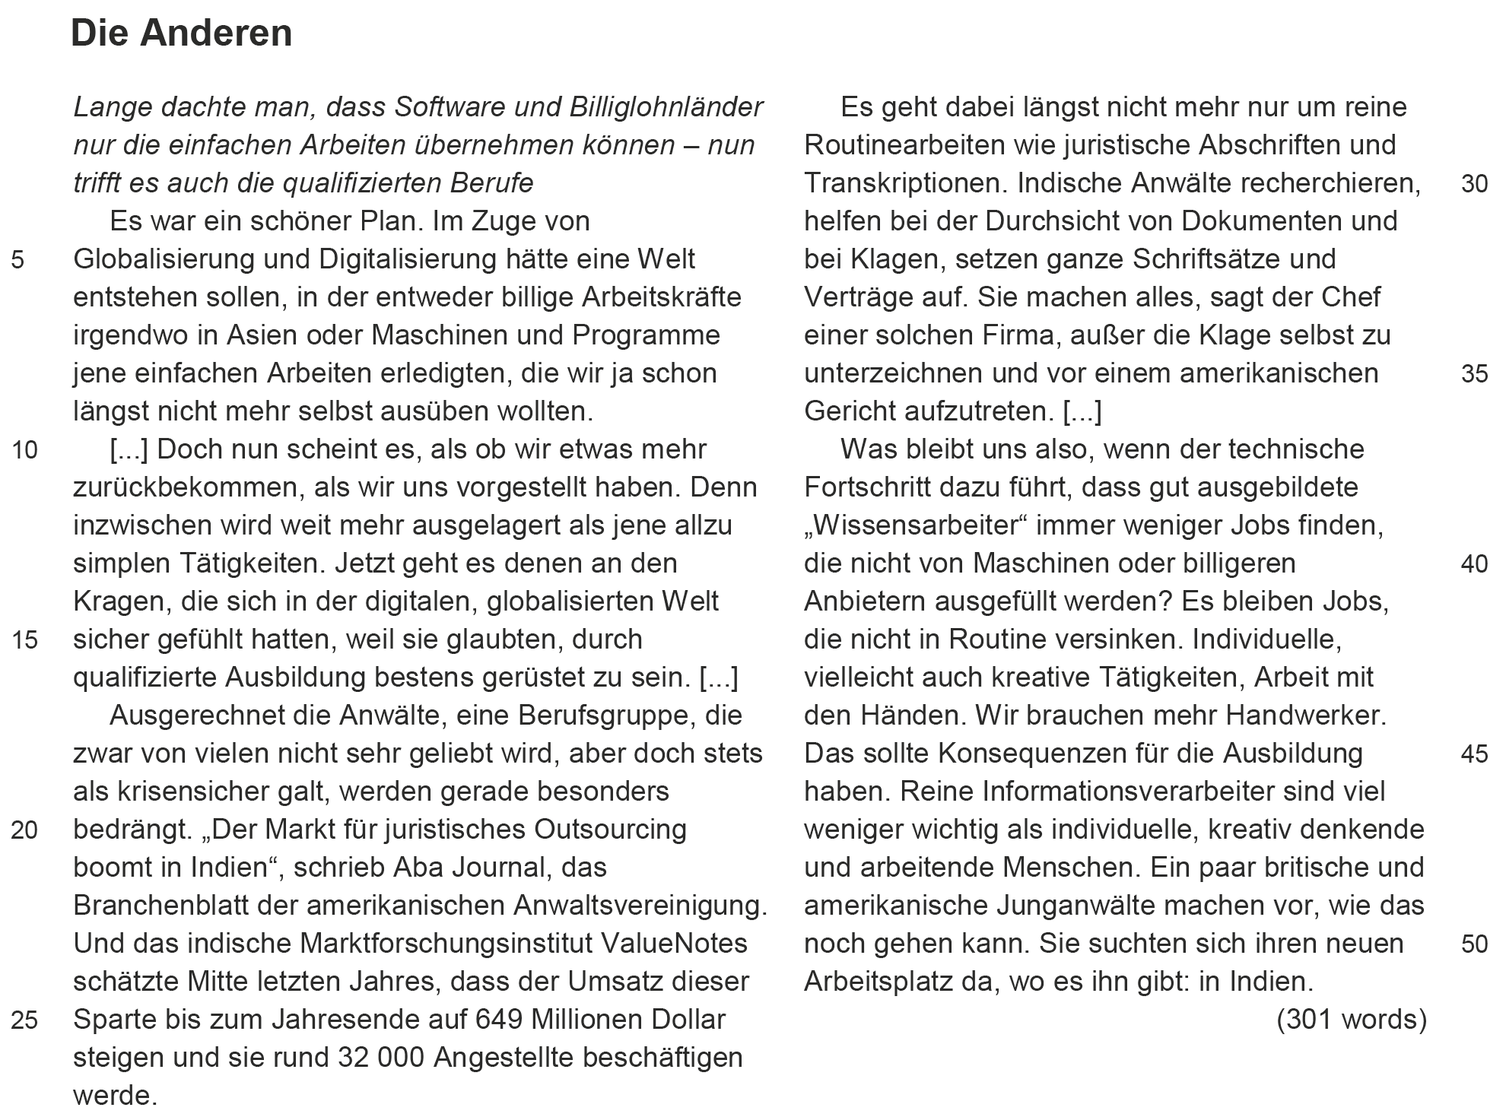

Erwartungshorizont
Textinformationen
Autor Cahal Milmo
Titel A 4G future: Four generations in same workplace by 2030 and more women
Quelle The Independent, 3 March 2014, http://www.independent.co.uk/news/uk/home- news/a-4g-future-four-generations-in-same-workplace-by-2030-and-more-
women-9163934.html (geprüft: 23.02.2015)
Textformat (Textlänge) Zeitungsartikel (532 Wörter)

Autor Petra Steinberger
Titel Die Anderen
Quelle Süddeutsche Zeitung, 16. April 2011, http://www.sueddeutsche.de/
gesundheit/internetabhaengigkeit-elektronisch-gefesselt-1.1822094
(geprüft: 23.02.2015)
Textformat (Textlänge) Zeitungsartikel (301 Wörter)
1 Content/Comprehension
Point out the major changes in the workplace that are predicted in the article.
The predicted changes include intergenerational work teams, replacing professionals with computer algorithms, an increase in the number of women in top positions, a divided job market and growing competition from countries in the Far East. According to the study by the UKCES there will be four-generation offices by 2030 whose employees will be between 25 and 75 or even 80 years old. Thus the youngest employees will work alongside colleagues who are the same age as their grandparents. The study also predicts that many professionals working in accountancy or doing legal work will be replaced by computer programmes. This implies that those professionals will have become superfluous. The next change refers to the increasingly important role women will play in highly skilled jobs and, in particular, in leadership positions. The developments will also entail a sharp labour market divide in which a highly skilled minority earns large incomes and a large low-skilled workforce with low incomes will face increasing competition from such countries like China. This competition may well lead economic disruptions and even to reverse migration with people leaving the UK due to the lack of job opportunities.

2 Form/Analysis
Examine the structure and style of the article. In doing so, consider the writer's choice of words when describing the future workplace.
The article is a typical example of a news story. It can be divided into three parts. The first part runs from line 1 to line 14. The opening lines – printed in italics and in bold letters – serve as a lead-in which introduce the subject, i.e. the changes in the workplace. Some of these changes are referred to in the subsequent lines, and the first part serves as an introduction. The central part of the text runs from line 15 to line 62. Here the writer expands on the ideas introduced in the first part by presenting detailed examples. The final part (ll. 63–71) mentions the potential economic and social ramifications, which lends the article a somewhat grim view of future developments.
The language of the text is straightforward and very matter-of-fact. The writer does not use emotionally charged adjectives and almost always avoids editorial comment. Instead, he enumerates the findings of the study and presents its predictions in a neutral way. Hence he carefully balances the advantages and disadvantages, e.g. he mentions the greater diversity of the workplace alongside the increased inequality that it will entail. Only once does he avail himself of words which express a critical view when he speaks of the possibility of “new sources of social strife” because younger workers might find themselves “trapped in low-level jobs”. However, he immediately seeks to substantiate this critical view by quoting one of the co-authors of the study who serves as an authority on the subject.
His neutral stance becomes increasingly apparent in the last part. Here he speaks of possible disruptions and the growing costs of healthcare and pensions that the government will face in the future, which will greatly limit its ability to fund “employment and education initiatives”. So all in all the text serves as a good example of a balanced and objective news story.
3 Comment/Text production
a) Write an email to the author of the article, Cahal Milmo, in which you either favourably or critically deal with some of the ideas mentioned in his article.
1. Positive feedback
Dear Mr Milmo
I read your article on the 4G future with great interest. You have given the reader a very detailed account of what future developments will be like in the workplace.
I am afraid you are right when you point out that in the future the job market will be marked by a sharp divide between a few high-skilled employees and a large number of low-skilled workers and the growing social and economic differences that will accompany this development.
I am worried that this will lead to social unrest and might even split our country into a small group of ‘haves’ and a large majority of ‘have nots’. I am wondering whether the study by the UKCES mentions any ways of dealing with this problem. If so, it would have been a good idea to include that information in your article.
Sincerely yours
…

2. Critical comment
Dear Mr Milmo
I read your article on the ‘4G future’ with great interest. You have given the reader a very detailed account of what future developments of workplaces will be like.
However, I am afraid you have painted a very negative and possibly one-sided picture of the future workplace. For example, why should young workers be trapped in low-level jobs as “older staff remain longer in senior positions”? Will employees no longer be assessed by their performance? Does seniority mean that older people will have guaranteed positions?
It seems to me that you are trying to stir up public opinion against intergenerational teams here. In addition, I disagree with your brief reference to “potential disruptions”. How likely is it that British employees would leave the country in order to find jobs elsewhere? Since you indirectly quote from the study, it might have been a good idea to add some information on the likelihood of the grim future with which you end your article.
Sincerely yours
…

b) Comment on the vision of four-generation offices. To what extent do you find this viable or undesirable from your generation's point of view?
The article presents the findings of a government-sponsored study on the future of work in the UK. One of the study’s predictions refers to four-generation offices in which employees in their 70s and 80s will work alongside people in their 20s. If this prediction comes true by 2030, it will entail serious implications such as culture clashes or the lack of advancement for younger generations. It is interesting to note that the advantages of four-generation offices are ignored in the article. If four generations work together in a team, there is a potential for better performance because the relative advantages of each age group would be complemetary. Just consider the amount of expertise older professionals have acquired over the years which they can pass on to younger professionals. And younger professionals can contribute fresh ideas on how deal with tasks and problems at hand. The combination of expertise and the spirit of innovation and drive could produce unprecedented results. So it seems to me that the “intermingling of generations” will not necessarily lead to “social strife” but instead could provide fresh and promising approaches and increase company output.

4 Mediation
Your English course is working on the joint project ‘The world of work – currents trends’ with your partner school in the UK. Together with your British partner you are working on the problem of outsourcing. You have come across Petra Steinberger’s article in the Süddeutsche Zeitung, which you find interesting. Present a short summary and send it to your partner.

The excerpt from the Süddeutsche Zeitung is about the globalisation of professional legal work. Originally, it was thought that globalisation meant only the outsourcing of simple menial labour to low cost countries. But now the work done by legal professionals is being outsourced as well. There are some 32,000 people in India doing legal work for American law firms. Not only do they conduct routine tasks such as copying or transcribing documents, but Indian lawyers also draft statements and contracts, and they conduct all kinds of legal work apart from representing a client in an American court.
The author wonders what kind of jobs will remain secure in the future if even professional workers run the risk of being replaced by low-cost professionals. She concludes that creative manufacturing jobs which don’t involve routine work will be the important jobs in the future.
It is difficult to imagine that German lawyers would be replaced by Indians because of the language barrier. However, professional workers in multinational companies, where employees use English as their lingua franca, might face difficulties in the future. For example, German chemical manufacturing might be outsourced to an Indian laboratory. Whether local plumbers or electricians will have job security depends a great deal on how wages develop within the EU.

